Benedictus Alvian Sofjan

3035603095

COMP3230 Tutorial 3 Exercise 2

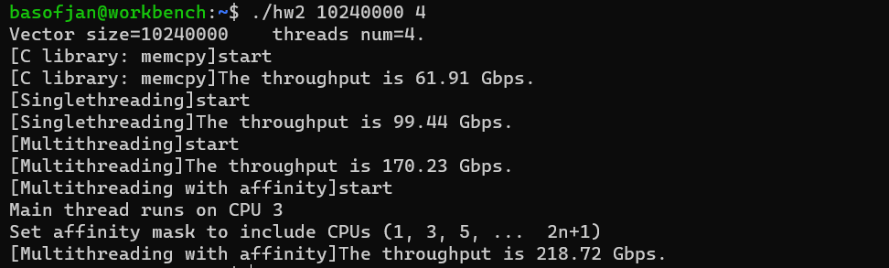Performance Evaluation

It is immediately apparent that C library’s memcpy has the lowest throughput, multithreading increases the throughput of the program and setting an affinity mask with multithreading further increases the throughput of the program.